CAR AVAILABILITY (Manual Changes)

/FOR P301
/FOR B301 (Budget)

This screen allows the user to verify the availability status for all car classes at a location for the next 30 days. Field Operations updates this screen.

CODE: 01
ACTION: S
RENT STA: 4-digit location code
ENT DATA: ddmmmyy

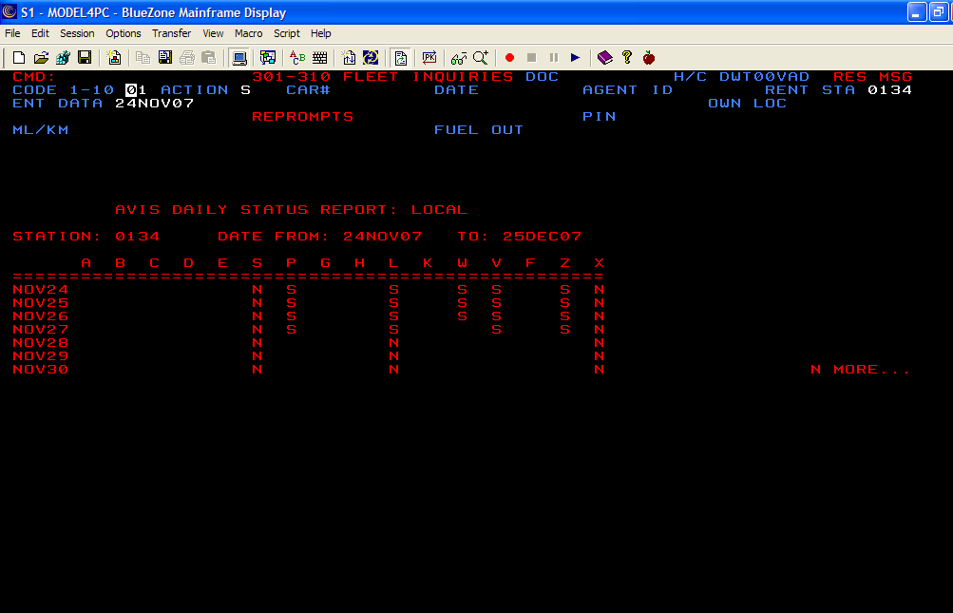
A = available
S = suspended
N = not in fleet
R = on request only
/FOR P502
/FOR B502 (Budget)

This screen allows the user to verify car class availability for all cars on an hourly basis.

PAC: DA
STA: checkout location

ETA: checkout date
ILC: return location
ETT: return date (not required)
EQP: all(for all standard cars); X for (

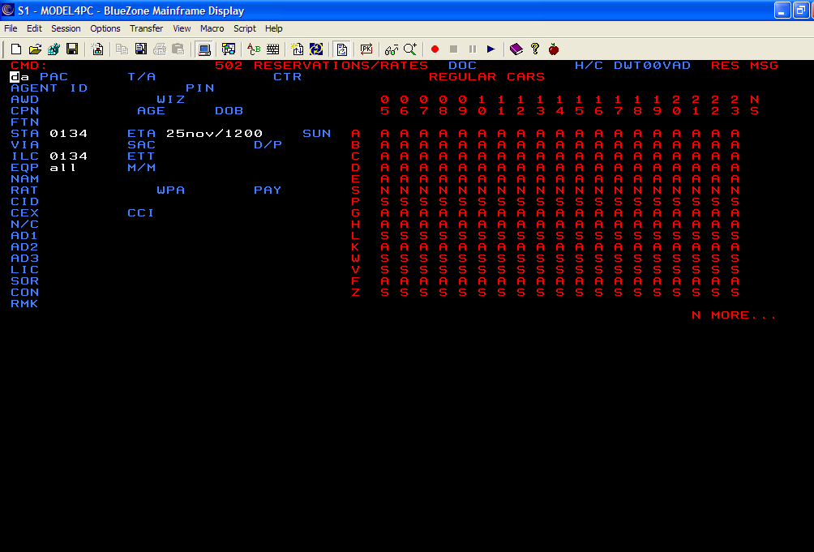

A = available
S = suspended
N = not in fleet
R = on request only

/FOR AVLLORU
/FOR AVLBLORU (Budget)

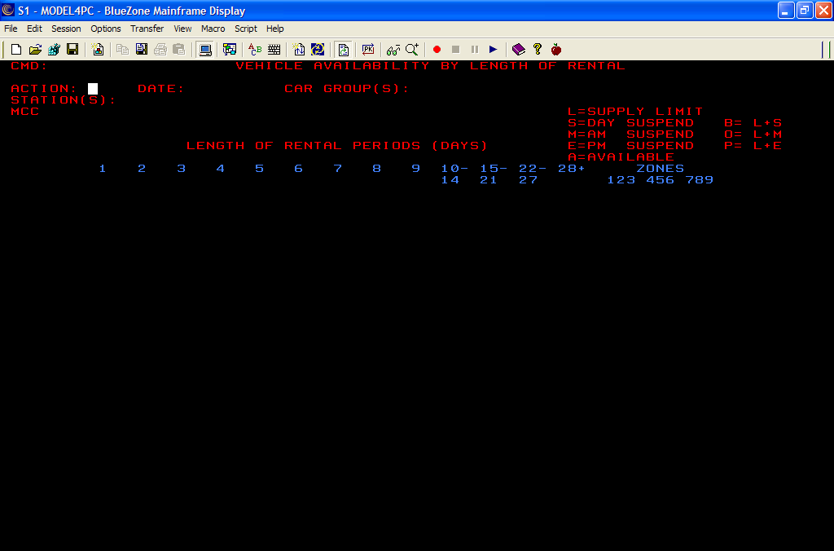

The Availability by Length of Rental system is a means to control the availability of certain car groups based upon length of time requested for a particular reservation. What this means is that with this system, we can dictate which lengths of rental we want and which we want to turn away. If, for example, two reservations both request the same car over a holiday weekend, we can refuse the one-day rental while accepting the three-day rental.

During a rate shop, best buy, or reservation transaction in the p502 screen, the system will first evaluate vehicle availability based on the length of rental controls. The screen will reflect any LOR data if applicable. For the display availability transaction, if a check-in date and time are entered, LOR data will show if available for that station, date and car group displayed.

SCREEN ACTIONS
DISPLAY (DIS)

Description:

This function displays an entire month for one car class and one station at a time.

Mandatory Fields:

ACTION: DIS
DATE: MMMYYYY (Ex: nov2007)
CAR GROUP(S): Car class
STATIONS(S): 4 digit station code
MCC: Blank for standard Cars; “X” for Cool Cars

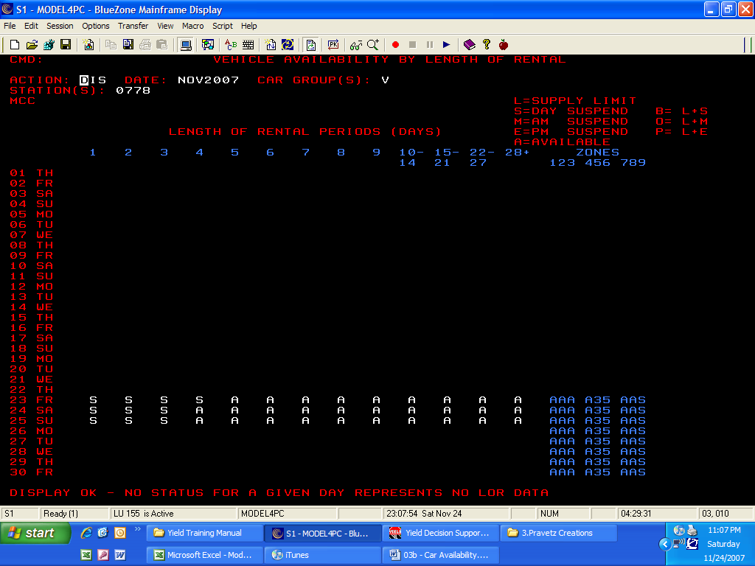

SCREEN ACTIONS
UPDATE (UPD)

Description:
This function allows the user to update the availability status for the specified cars, locations, and LOR buckets.

Mandatory Fields:

ACTION: UPD
DATE: MMMYYYY (Ex: apr2007)
CAR GROUP(S): Car class (up to 16 at once)
STATIONS(S): 4 digit station code ( up to 20 at once)
MCC: Blank for standard Cars; “X” for Cool Cars

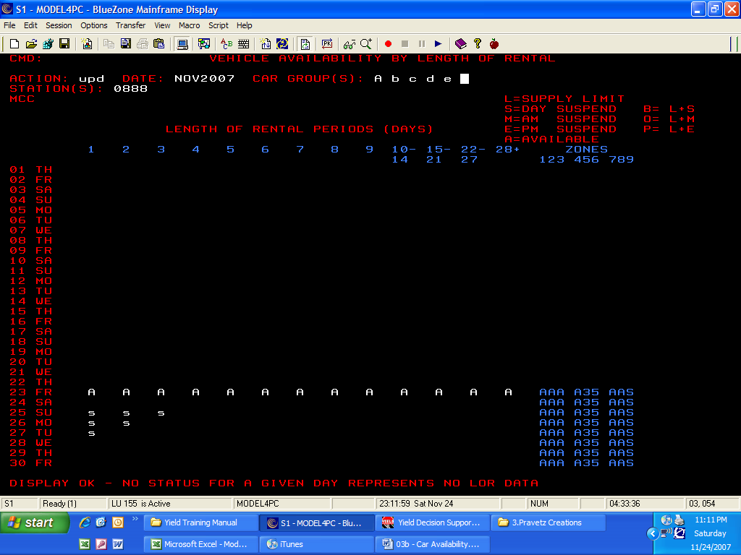

/FOR STDSTATS
/FOR STDBSTAT (Budget)

This functions shows the actions taken by the field for a specific date.

Mandatory Fields:

ACTION: DIS
DATE: MMMYYYY (Ex: nov2007)
CAR GROUP(S): Car class
MCC: Blank for standard Cars; “X” for Cool Cars
STATIONS(S): 4 digit station code

- 